**ONLINE PIZZA DELIVERY SYSTEM**

**SOFTWARE REQUIREMENTS SPECIFICATIONS DOCUMENT**

HARIKRISHNAN KS

U60900 ALPHA

**Table of Contents**

1. Introduction 3

1.1 Purpose 3

1.2 Intended Audience 3

1.3 References 3

1.4 Overview of document 3

2. Description 4

2.1 Features and Functions 4

2.2 User classes and Characteristics 4

2.3 Operating Environment 4

Hardware…………………………………………………………………….. 4

Software……………………………………………………………………... 4

3. Specification Requirement 4

3.1 Performance Requirement 4

3.2 Overview of Data Requirements 4

3.3 Technologies Used5

**4. Class Diagram**

**5. ER Diagram**

**6. Conclusion**

**7. Screenshots**

**INTRODUCTION**

**1.PURPOSE**

The Pizza Ordering System is a Web Application which facilitates ordering pizza from anywhere. The customer is able to view the menu, logs in enters his/her credentials , place orders, and even book seats in restaurant .This system is to override the problem prevailing of manual placing of order. This system ensures the entry of invalid data and easy and convenient mode of ordering the pizza. The organization can keep customized records without redundant entries. The system ensures how to manage for good performance and better service of client.

**1.2 INTENDED AUDIENCE**

The project is carried out with in the UST GLOBAL premises and meant to be used with the organization.

**1.3 REFERENCES**

1. [www.stackoverflow.com](http://www.stackoverflow.com)

2.GitHub

3. w3Schools

**1.4 OVERVIEW OF DOCUMENT**

The first section of SRS gives a brief introduction on Online Pizza Management System. This section also provides the reference information for further study, intended audience and need & purpose of the product. The second section provides an overall description of the application, product features & functions, users and operating environment (hardware, software and external). The third section is about the specific requirements like external interfaces, performance requirements, design constraints and additional comments.

**2.OVERALL DESCRIPTION**

**2.1 PRODUCT FUNCTIONS**

2.1.1 Login

The system allows the user to view the menu and login with user credentials to place order. It checks for valid user and allows to place order or reserve seat.

2.1.2 Registration

If the user is a new customer they are asked to register .The data entered is checked is valid or not if valid they are allowed to place order or reserve seats.

2.1.3 Reserve Seat

The user can reserve seats if available for a particular day. The maximum number of seats available for a day is limited to 10.

2.1.4 ORDER PIZZA

The user can order multiple pizzas of any size with multiple toppings.

2.1.5 CANCEL ORDER

The user can cancel order and get the refund.

**3. REQUIREMENTS**

**3.1 SOFTWARE REQUIRED**

This project is implemented in Spring-Hibernate MVC and execution of the project is done using jdk1.8 or Eclipse IDE. As we know JAVA is a platform independent language so this software runs with JRE environment on any desired platform i.e. Windows 10, XP, or 2000 or any operating system.

**3.2 HARDWARE REQUIRED**

Any computer, laptop system is sufficient. It’s a network based software so computers connected with any kind of mode (wireless, LAN connected etc…) will suit its requirements. It can also be run on a single machine for its demo use.

**3.3 TECHNOLOGIES USED**

* **IDE:**

Eclipse Java EE IDE (Neon)

* **FRONT END:**

JAVA, HTML, JSP, Javascript

* **Back End:**

MySQL, HQL

**4. CLASS DIAGRAM**

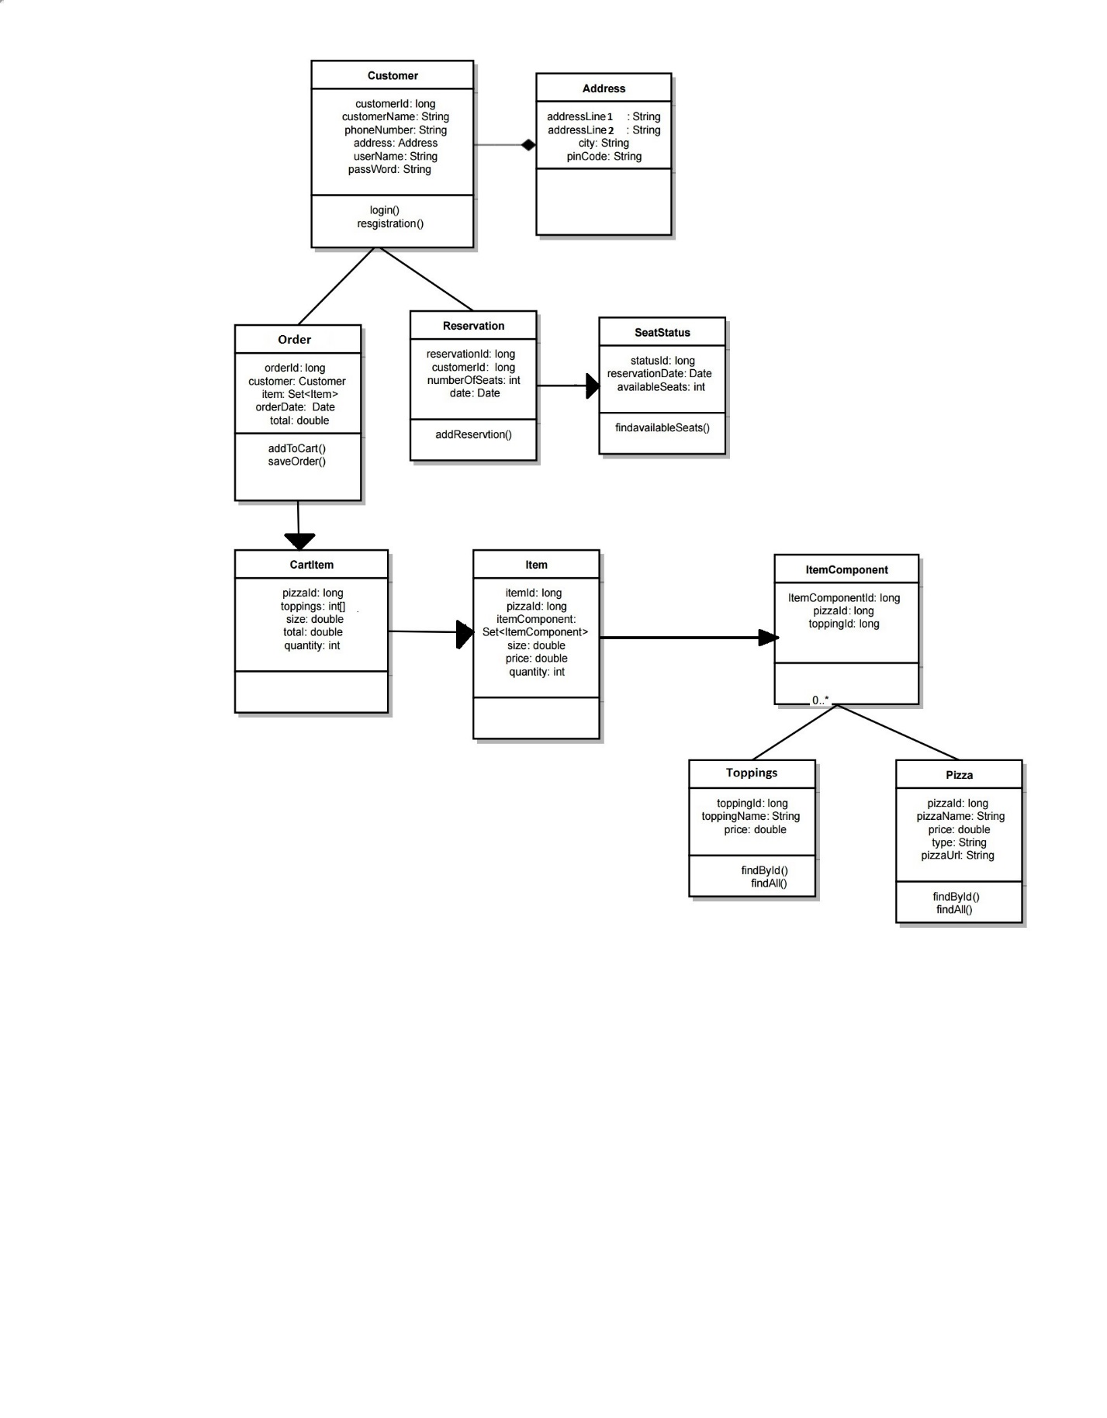

**5.ENTITY DIAGRAM**

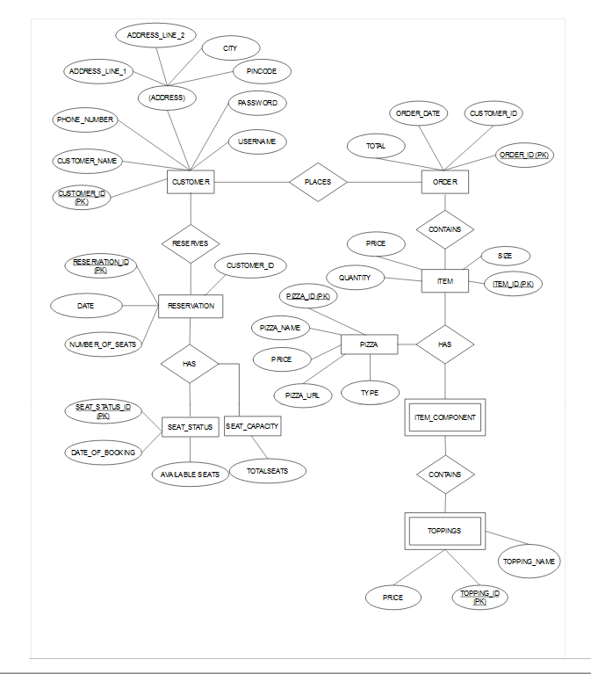

**6.CONCLUSION**

This project is developed to satisfy the need of pizza customers in a simple way. In this pizza delivery system, registered users can perform customized pizza ordering with a view menu card and also there is a seat reservation system at any time through a single button click. This application thus standardize the system with database features which allows customers to review the order details such as the total price and also give a different experience in selection processes. Moreover, this application provides simple user interface.

**7. SCREENSHOTS**

**Login page**

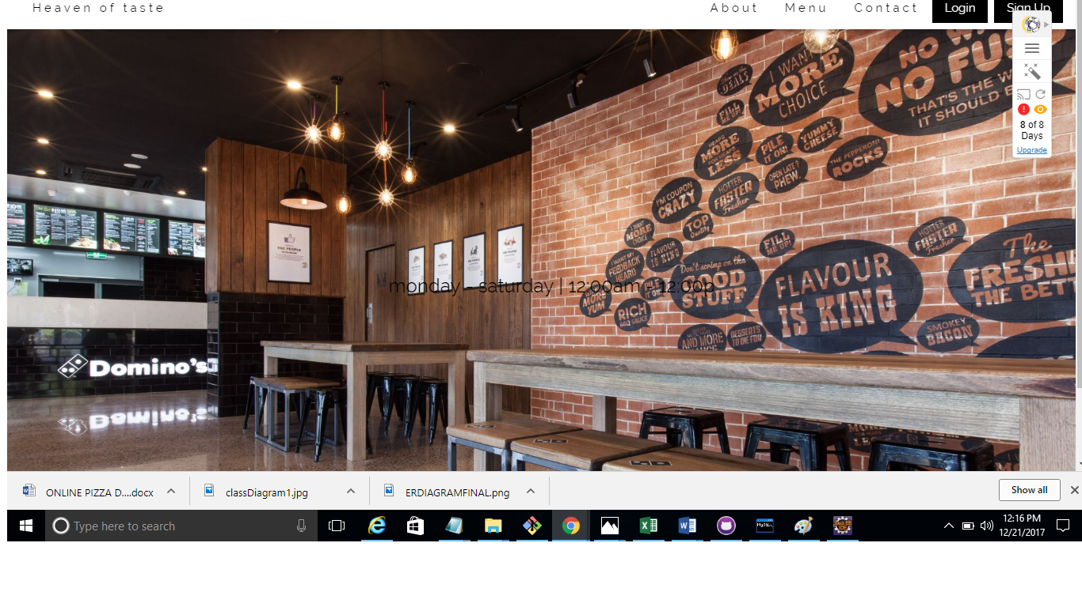

**Registration Page**

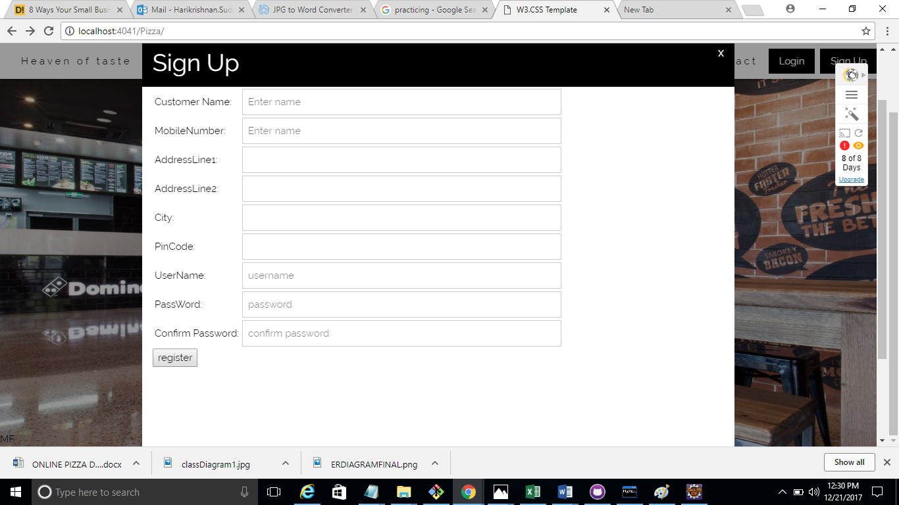

Cart Page

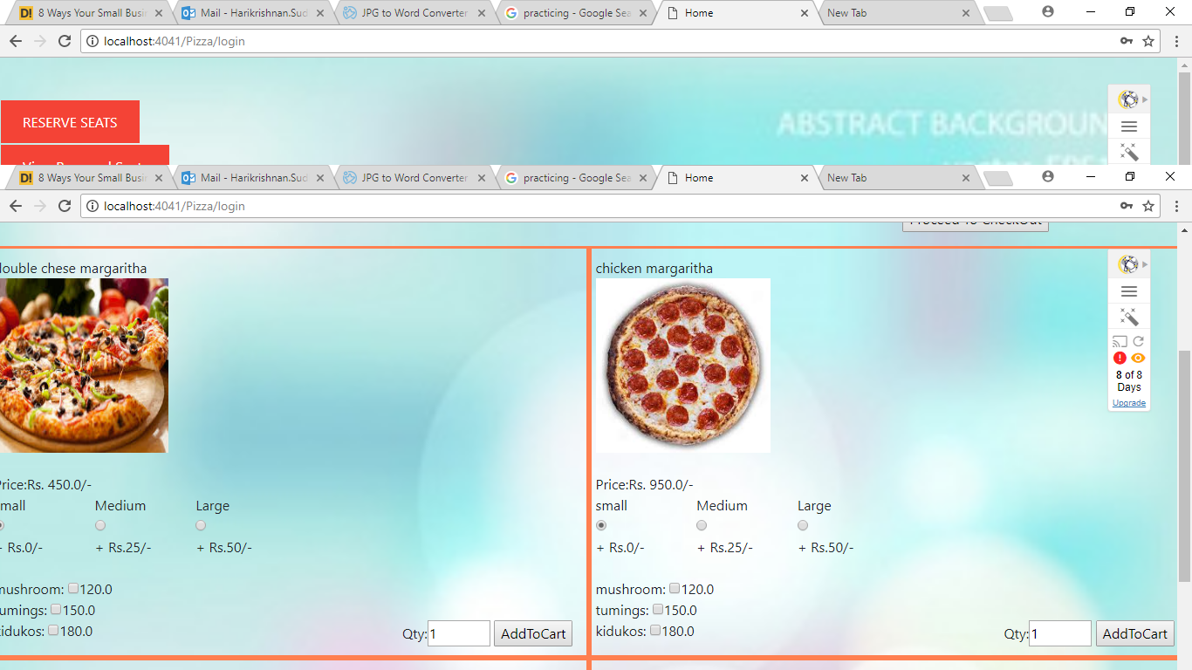

**Check out Page**

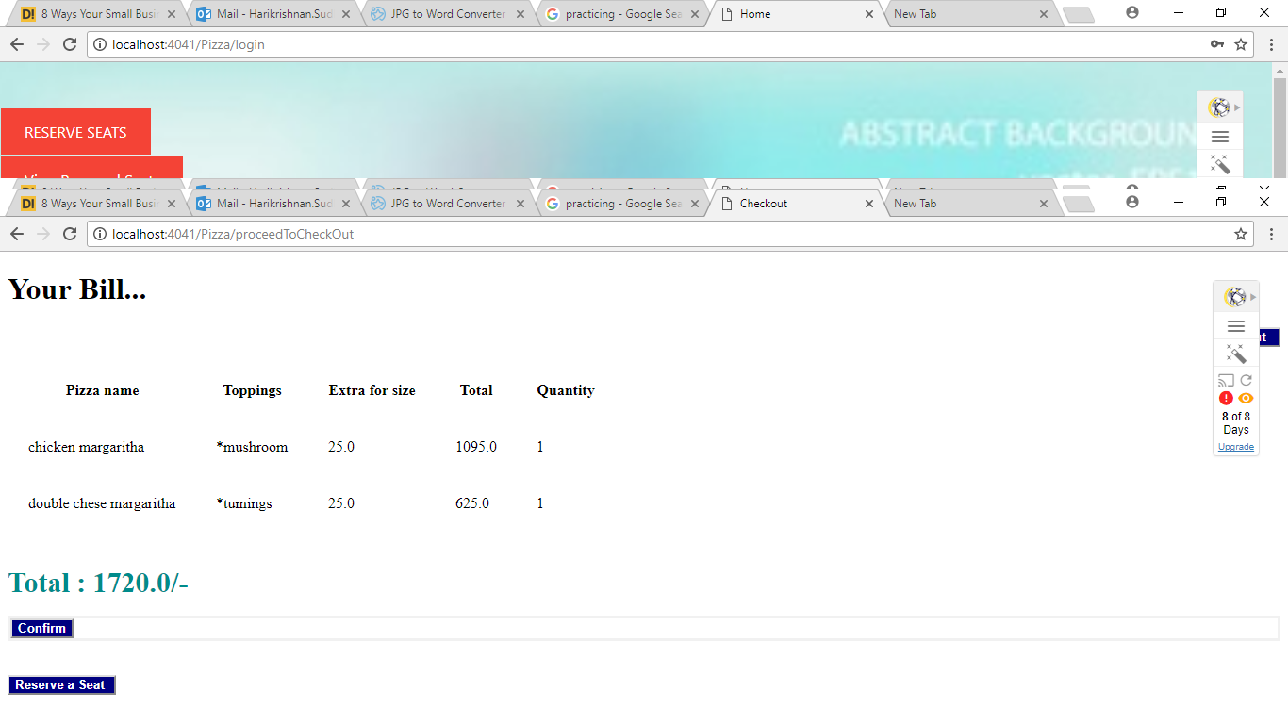

**View Order Page**

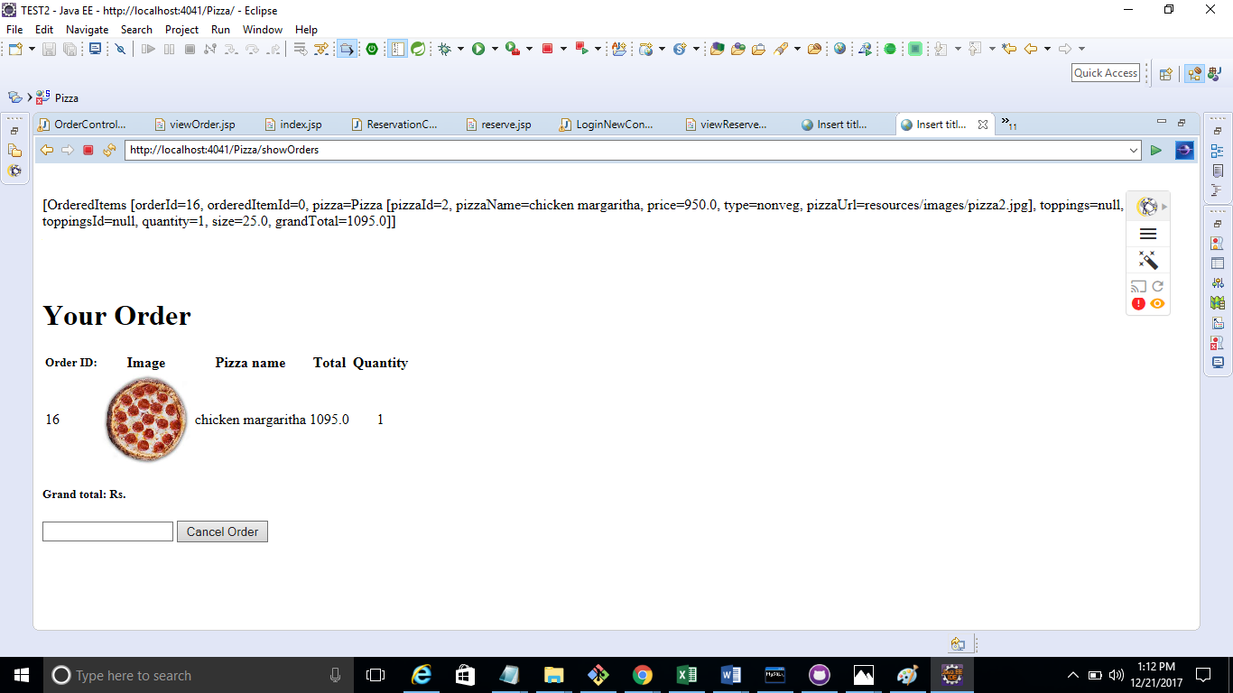

**Seat Reservation Page**

